**Voting Applications**

**for Cal Poly Club Leadership**



**Team Voting App**

**Michael Golahi, Isamar Hernandez, Bryan Sugiarto, Brandon Vo**

**Table of Contents**

1.0 Introduction 1

1.1 Minna No Anime Background 1

1.2 Problem Statement 1

1.3 Purpose 1

1.4 Research Methodology and Analysis 1

2.0 Research Results 2

2.1 Part 1: Case Studies 2

2.1.1 Email 2

2.1.2 VoxVote 3

2.1.3 Mentimeter 4

2.1.4 GroupMe 5

2.1.5 Google Forms 6

2.2 Part 2: Interview and Survey Results 7

3.0 Proposed Solution 8

4.0 Conclusion 8

5.0 Appendix 9

**Table of Figures**

Figure 1: Email Screen 2

Figure 2: VoxVote Question Creation 3

Figure 3: VoxVote Question Results 3

Figure 4: Mentimeter Question Creation 4

Figure 5: Mentimeter Question Results 4

Figure 6: GroupMe Screen 5

Figure 7: Google Forms Voting Screen 6

Figure 8: Google Forms Results Screen 6

Figure 9: Our Google Form for Survey 9

Figure 10: Our Google Form Results 9

Figure 11: Our Results in Spreadsheet form 10

**Introduction**

**Minna No Anime Background**

Cal Poly’s anime club, Minna No Anime is a club on campus oriented around Japanese animation. Minna No Anime’s leadership consists of Isaac Cameron, Justin Alday, Eric Oatey, Curtis Hilgenberg, Nicole “Mouse” Martin, Emily Mullins, and Scott Melot. According to Secretary Curtis Hilgenberg, the club’s leadership lacks a quick and efficient way to communicate for club decisions, and he suggested a voting mobile app would be helpful.

**Problem Statement**

The Cal Poly anime club, Minna No Anime, does not have an efficient method of voting on decisions for the leadership committee. The club currently uses an email thread as their method of decision-making. It has proved ineffective as a voting system as emails can get lost or sent to junk mail leading to delays in decision-making. The lack of an efficient voting system has delayed some decisions.

**Purpose**

The purpose of this project is to come up with the best voting systems for the club to use. The project will attempt to establish an efficient method through research on different online platforms commonly used for voting such as Doodle, Google Forms, Survey Monkey, etc.

**Research Methodology and Analysis**

The two research goals are to

1. Research viable solutions to Minna No Anime’s communication issue.
2. Research which solution in Part 1 is the most efficient and ideal solution for clubs to use.

For Part 1, we would utilize our general knowledge as consumers, interviews with various Cal Poly club officers, and analysis reports on different online survey tools to find solutions to the communication issue. We will also be looking at articles and databases to figure out what methodologies professionals use to conduct decision-making. The end result to our research will be our own case study reports giving the benefits and disadvantages of the best solutions.

For Part 2, we mainly interviewed clubs on campus to find which solution they prefer.

Our primary source of data will be an interview with Curtis Hilgenberg. We believe that reaching out to the Minna No Anime, the group that is directly experiencing issues with decision-making methodology, will give us a better idea of the involved issues. We also interviewed three more students who are officers of their respective clubs. In addition to the interviews, we created a survey to ask members of various Cal Poly clubs which voting application (or methodology) they use the most.

Combining the results of Part 1 and Part 2 will give us a better idea of which voting methodology is the most suitable solution for the Minna No Anime.

**Research Results**

**Part I: Case Studies**

Below are the case studies for Email, VoxVote, Mentimeter, GroupMe, and Google Forms.



**Overview**

Electronic mail or email is a method of exchanging digital messages from an author to one or more recipients. Email operates across the Internet through a mail server. An email message usually consists of three components: the recipients, the message header, and the message body. The header includes descriptive information such as the subject header field, a message submission date/time stamp, and the names of the recipients of the message. There are many software platforms available to send and receive. Popular email platforms include Gmail, Hotmail, Yahoo Mail, Outlook, and many others.

**Benefits**

* 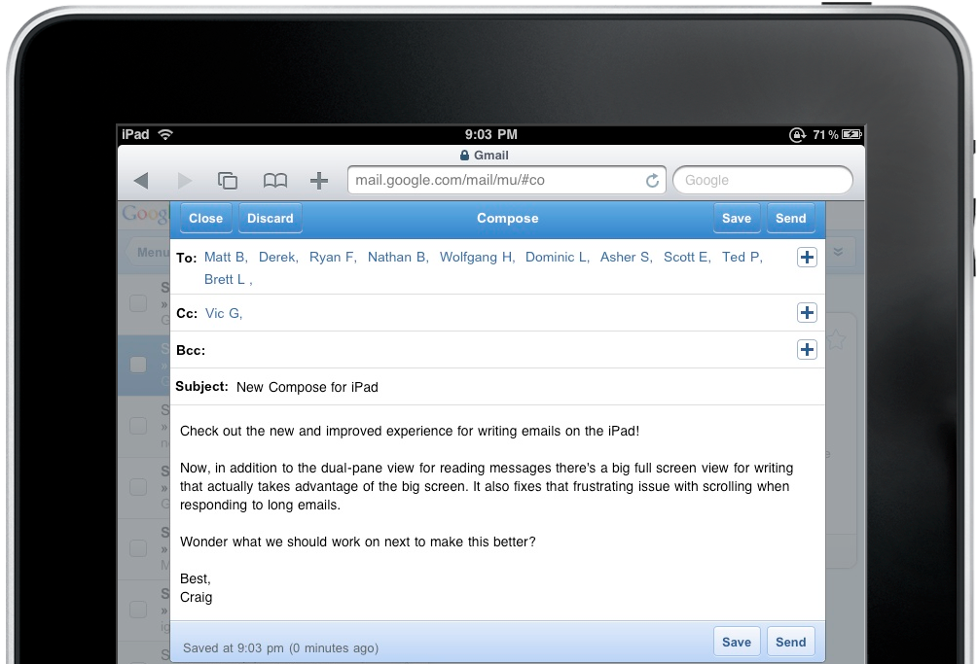The messages are instantly sent and received.
* Each message is in a thread that is organized.
* Everyone can respond to the thread
* Everyone can send and receive the message.

**Disadvantages**

* Messages can be accidentally placed in junk mail.
* The number of email messages in an inbox can be overwhelming.
* Users are not immediately

notified of new mail.

**Figure 1:** Email Screen

creen Shot 2015-11-17 at 8.41.12 AM.png

**Overview**

VoxVote is a voting application that is geared towards mobile applications. VoxVote was created by a software company based in the Netherlands. The application has been used by a plethora of companies and universities for various events. Some of these include Duke University, Cisco, Porsche, Coca-Cola, and IBM. VoxVote’s main selling point is that it allows the users to easily create questions, quickly answer, and view the results in live time. Question creation occurs online at voxvote.com. After a user logs in they can navigate to VoxVote Designer as seen in figure 2 where all the user needs to do is to type in the question, the possible answers, and some options like is the question is single or multiple choice. In order to vote the user must download their mobile application that is available on Android and iOS. Where they type in a five-digit event id and then can select the question to vote on. As votes are coming through the website the user can view figure 2 where the user can start or stop the voting process and view the distribution of results.

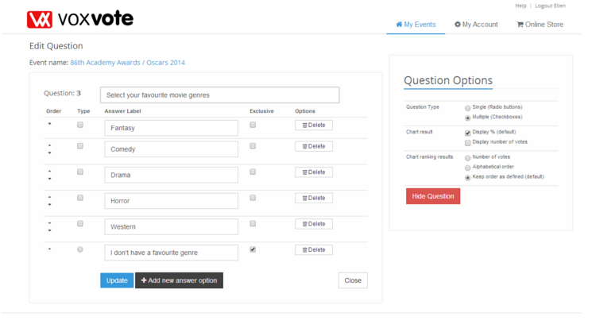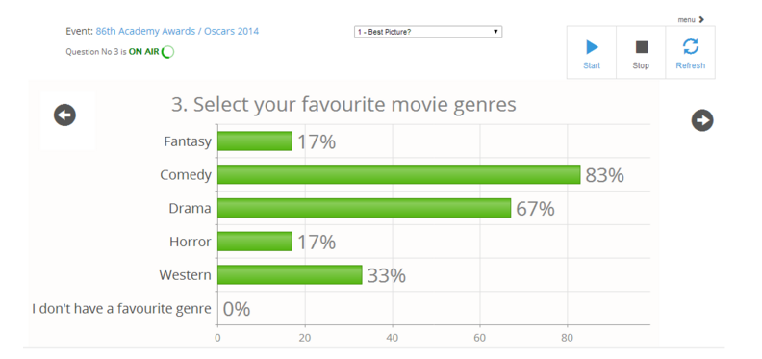

**Figure 2:** Question Creation **Figure 3:** Question Results

VoxVote adopts the “freemium” model of software pricing. The application is free to use for ten events and each event is allowed up to ten questions. Afterwards for additional events VoxVote charges about €15 per event depending on how many is purchased. Although for teachers, students, or anything that is affiliated with a university VoxVote provides unlimited events and is completely free.

**Benefits**

VoxVote is a very simple and intuitive application which can harness quick results through an easy voting process other benefits include:

* Quick and easy vote creation.
* Expedited voting process.
* Unlimited number of voters allowed so the entire club can vote on issues if necessary.

**Disadvantages**

VoxVote has cons very similar to other applications like Mentimeter and they are:

* All voters need to have a smartphone.
* In order to receive unlimited free events the club has to register and be approved to receive educational user status.



***Overview***

Mentimeter is a web-based tool for creating interactive presentations. The idea behind it is to allow users to ask a large audience questions via a presentation and to get responses immediately. The workflow is outlined as follows:

1. User adds questions and available responses to a presentation as seen in Figure 4.
2. User instructs their audience to visit <http://vot.rs> on their mobile phone, and enter the unique ID provided by the user, which routes them to the user’s presentation.
3. Audience accesses the questions and provides an immediate response to each one.
4. Mentimeter displays the poll results in real time (question by question) for the user to display on the presentation as seen in Figure 5.

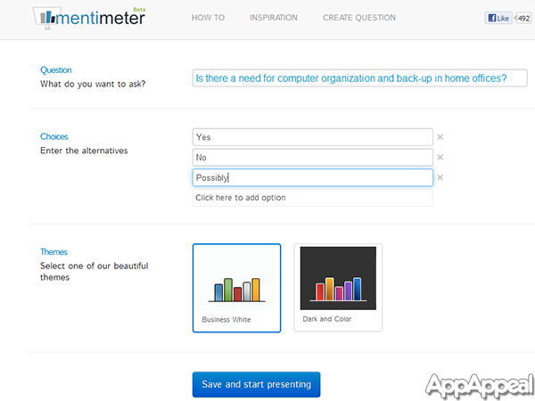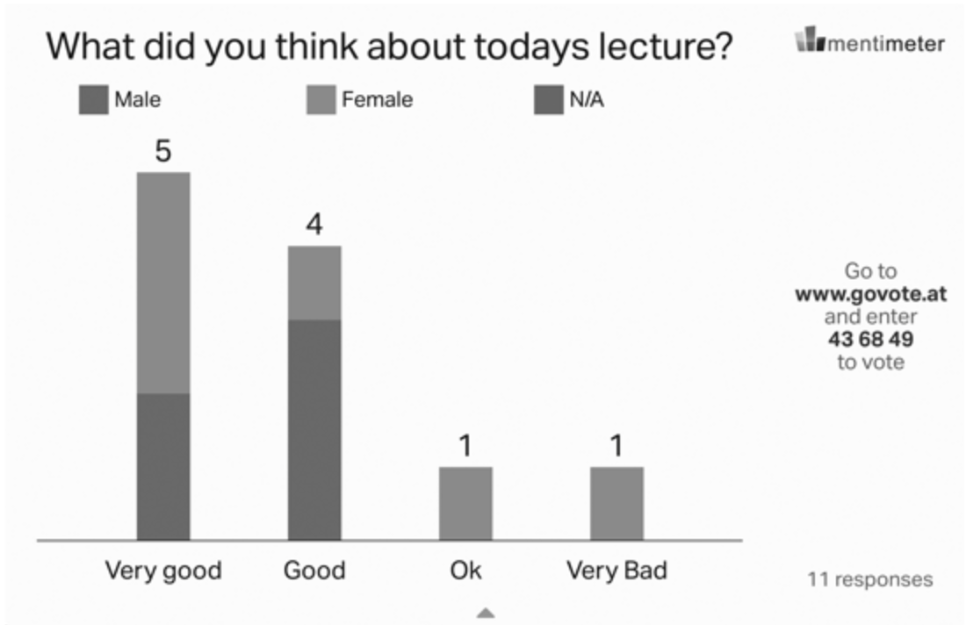

**Figure 5:** Question Results

**Figure 4:** Question Creation

***Benefits***

Mentimeter has the potential to be very useful during a presentation where all participants are working collaboratively. This is due to its real time results feature, which facilitates discussion about results and enables the group to immediately flush out any controversy. All versions of Mentimeter implement the following beneficial features:

* View results and make analysis in real-time.
* Vote on several questions in a row - presenter controls when they vote.
* Unlimited use - Mentimeter handles up to 30,000 votes per minute.
* PowerPoint plugin to create questions and get real-time input.
* Several question types (multiple choice, scale from 0-5, free text, matrix input).
* Several result types (bar/pie charts, word cloud, trend analysis, matrix result).

***Disadvantages***

Mentimeter would be impractical if any individuals of the group wanting to take a poll would not be available at the same time - it was developed with real-time group collaboration in mind so asynchronous question taking is not an available feature. In addition to this, Mentimeter falls short because of the following:

* Free version is limited to 2 questions and data is not private.
* Paid versions are expensive for a voting app ($7.99 and $19.99 per month for basic and pro versions, respectively).
* Cannot answer questions at your own pace, you must follow the presentation exactly.

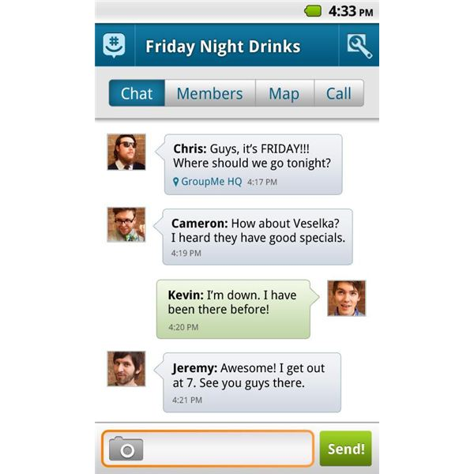

**Overview**

GroupMe is a mobile group-messaging app owned by Microsoft launched in May 2010 by the private company GroupMe. In the month of June 2012, 550 million messages were sent using this application.

The application allows you to message multiple people at once and get the responses in a true group text. GroupMe acts as a Reply All button. This is done by setting up a dedicated number for each texting conversation, so when you text multiple people at once, they get a text message from that number. Then, when they reply to the text message, their reply goes to everyone in your GroupMe conversation. So it's like a group-chatting app, except via text message.

Besides the standard group chat, GroupMe also includes other features such as conference calling, a mapping service that shows the locations of the chat members, and an 'Ask a Question' feature.

**Figure 6:** GroupMe Screen

**Benefits**

Most of the benefits of using GroupMe are related to its ease of use and feel of a group conversation.

* Cross platform: users can use standard text, the Android application, or the iOS application, or the desktop application to send GroupMe messages.
* The user does not need to have installed GroupMe in order for it to work.
* Instead of having responses to a group message individually via standard text, you can have all members of the group see everyone’s responses.

**Disadvantages**

* Once the group is disbanded, the private number will not exist.
* The ‘reply all’ features can be overwhelming.
* No confirmation of sent message.
* The participants of the group message do not have a voting platform.



**(Google Forms)**

**Overview**

Google Forms is an application available on a Google account.  The application lets you create a question and write out answers using a pre existing template. The user has the option of which question and answer format to use. The options include: multiple choice, short answer, grid, checkboxes, and choose from list.

The application then creates a form that you can send others a link to via email or social media. The users then fill the form and simply send submit. The creator has the option of limiting the number of times a person can vote. The application then collects the responses and creates a live-time response form that analyzes the number of responses and number of times an answer was given.

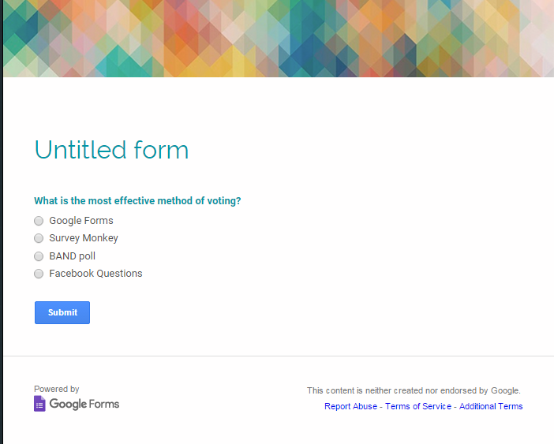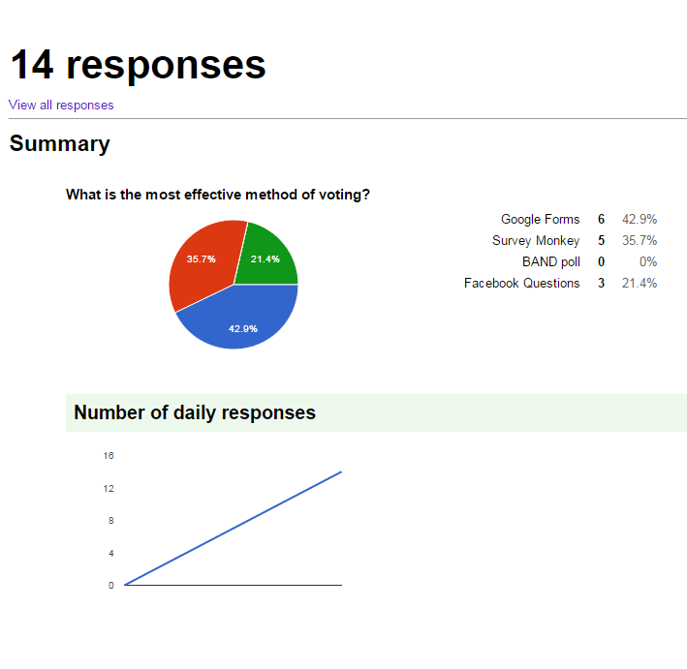

**Figure 7:** Google Forms Voting Interface **Figure 8:** Google Forms Results

**Benefits**

* Easy to use for voting purposes.
* Pre-designed templates create a hassle-free creation of a form.
* The app collects the data and analyzes it for you.
* You don’t need a Google account to vote.

**Disadvantages**

* You can only limit the answer to one vote if limiting at all.
* If there is no limit, there is no way of limiting answers.
* The form does not take into account who is voting.
* You need a Google account to create a form.

**Part II: Interview and Survey Results**

From our interviews with various club officers about internal club communication, we discovered that there are many aspects of their club communication process in which all four of our interviewees agreed on. The interviewees included Curtis Hilgenberg, Vania Tso, Jorgie Wu, and David Karditzas. Each are officers of different clubs on Cal Poly’s campus, and all of these officers answered eight questions which helped us find the right tool for their respective clubs. To view the entire interview, turn to the interview section in the Appendix. Some general preferences the four club officers agreed on are the desire for a free service. One officer stated he would pay for a voting service but the majority would not pay. Another general conclusion we got from the survey is the use of email. Currently, most of the officers use email as the primary form of communication. As a result, the most common problem for the officers is the speed of the communication process. Other issues include miscommunication resulting from using lengthy email exchanges and unread messages. For the Minna no Anime club in particular, the time in between discussing an issue and voting on it can take between 48 hours to several weeks. Ultimately from our interviews, the club officers desire a communication/voting service that is free, instant, and organized to avoid miscommunication and unread messages.

Compared to our interviews, the survey we used showed people had a clear preference of what tool to use for voting decisions. Our Google Forms survey gave people options to choose which communication service they would like to use. Out of the 14 responses given, 9 preferred Google Forms as the voting platform to use. The GroupMe application received 2 votes. Email, VoxVote, and Mentimeter each received 1 vote. To view the complete survey, please refer to Figures 9-11 in the Appendix.

**Proposed Solution**

By assessing the analysis reports for each application and the survey results, Google Forms seems to be both the most popular and effective voting mechanism. Therefore, we recommend the Minna No Anime to use Google Forms to vote on issues, with the condition that they limit the poll to one answer per person.

Keeping this one condition in mind, Google Forms is exceptionally beneficial for both the poll creator and the rest of the leadership committee. The poll creator is equipped with the ability to easily instantiate tests and instantly view results that are analyzed and beautifully formatted. The burden for other Minna No Anime officers is eased by way of a single link that takes the user directly to the poll, along with a user-friendly interface that is easy to navigate. Both of these features are provided without requiring any additional accounts or logins. In addition, the cost to transition to this plan is virtually nothing; the only precondition is that the poll creator must have a Google account to also view the results. There is also a myriad of options so the leadership committee can vote on anything from a simple yes/no question to a prompt that may require free response input.

The primary reason we selected Google Forms over other options was due to the fact that it is completely free while still maintaining flexibility and accessibility. It is the most robust and popular option, meaning that there is a large community available to answer questions if any problems arise in creating or taking a poll.

However, should the Minna No Anime leadership committee choose to select Google Forms, they must also be aware that it will cannot replace real time discussion. Unfortunately, Google Forms does not implement any features for two-way communication. However, we believe that Google Forms provides more than enough functionality for voting purposes, the primary issue faced by this club. For even more effective decision-making, Google Forms can be paired with any traditional forms of multi-channel communication such as face-to-face communication or even GroupMe. This allows the group to not only vote on issues, but also work towards solutions collaboratively.

**Conclusion**

Our team had the opportunity to analyze four different tools used for voting to determine which was the best to replace emailing for the Minna No Anime Club. In addition to the comparison of these applications, we conducted a poll using one of the applications that was suggested and gathered data on what other clubs currently use for voting purposes. After pooling all of this data together, we have concluded that Google Forms will enable the Minna No Anime club to vote on issues in a clear and effective manner.

**Appendix**

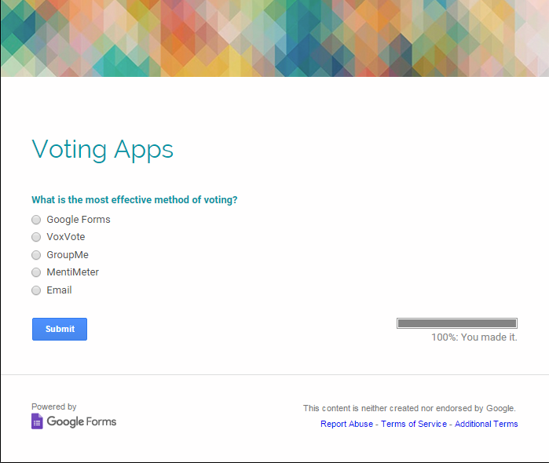**Figures**

**Figure 9:** The survey we created to test Google Forms but to also gauge what users prefer.

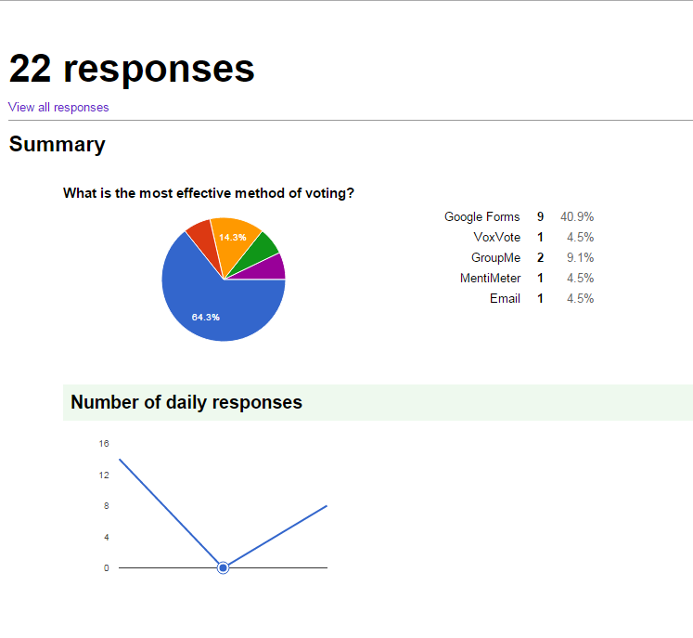

**Figure 10**: An example of how Google Forms analyzes data for the user based of real-time voting.

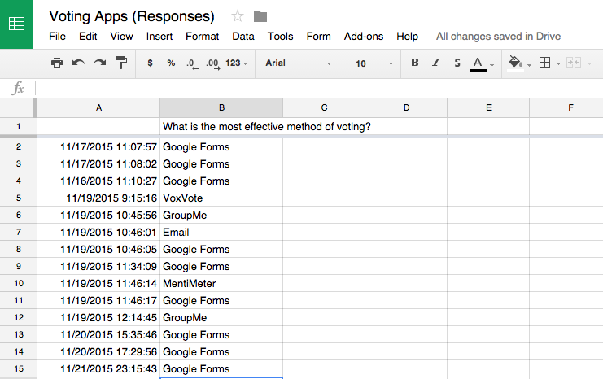

**Figure 11:** The following spreadsheet depicts the results from the survey conducted via Google Forms.

**Interviews**

Curtis Hilgenberg

1. What club are you currently in leadership for?

Minna no Anime, the Cal Poly anime club.

2. How do you currently communicate among the leaders?

Official communiqué is done through emails (There's an email alias that sends to all officers).

3. Would you prefer real time voting or voting at your own pace?

At my own pace.

4. Would you pay for any communication services?

Nope!

5. What is the average time between the start of the discussion and the decision?

Anywhere from 48 hours to a couple of weeks.

6. What problems have you encountered with your current communication process?

Emails getting buried and forgotten in our inboxes is the big one.

7. How many people are in the leadership team?

Seven.

8. Have you discussed using other communication methods for your leadership team?

Nope

Vania Tso

1. What club are you currently in leadership for?

Net Impact Cal Poly Undergrad

2. How do you currently communicate among the leaders?

Groupme, Email, Asana

3. Would you prefer real time voting or voting at your own pace?

Real Time Voting

4. Would you pay for any communication services?

No

5. What is the average time between the start of the discussion and the decision?

Depends on what's being discussed, but for general day to day club activities, probably about 5 minutes.

6. What problems have you encountered with your current communication process?

Slow responses

7. How many people are in the leadership team?

6

8. Have you discussed using other communication methods for your leadership team?

Yes

Jorgie Wu

1. What club are you currently in leadership for?

Epic, the Asian American ministry of Cru

2. How do you currently communicate among the leaders?

Weekly Leaders Meetings, emails, GroupMe chat, Facebook

3. Would you prefer real time voting or voting at your own pace?

Real time voting... I think??

4. Would you pay for any communication services?

Probably not

5. What is the average time between the start of the discussion and the decision?

For smaller decisions (ex Should we do prayer and worship night/some other event? Would this meeting time work for you? etc) about 5-10 minutes

For bigger decisions (ex Should we changed from mixed Bible studies to class Bible studies? What are some ways we can better implement evangelism? How can we better care for leaders? What should we go over in leadership meetings? etc).. these are discussed over a multiple of conversations across months/a longer period of time. Each conversation can be 1-2 hours, but it really depends on the topic and how many people are involved in the decision-making process :)

6. What problems have you encountered with your current communication process?

Because there are so many leaders to communicate amongst, I sometimes fear that people have ideas or opinions but few opportunities to communicate them, especially because our main form of communication during the week is through technology.

Also with emails/group texting/Facebook, there is always the risk that not everyone will see messages. Face-to-face would be ideal in getting everyone on the same page, but these meetings are short and only happen once a week.

7. How many people are in the leadership team?

30

8. Have you discussed using other communication methods for your leadership team?

No, would love to hear of other ideas/methods

David Karditzas

1. What club are you currently in leadership for?

Industrial Technology Society

2. How do you currently communicate among the leaders?

- Weekly face to face conferences

- Group communication applications such as Groupme

- Collaborative work is done via Google Drive and Microsoft OneDrive

- Formal communication via email (myCalPoly and Gmail)

3. Would you prefer real time voting or voting at your own pace?

- Real time voting

- *Depends on the situation, but real time data allows for quicker analysis and decision making.

4. Would you pay for any communication services?

Yes, if these communication services offered additional benefits than aforementioned tools currently used. Also if these services replaced these tools and brought them under one umbrella (aka one access point).

5. What is the average time between the start of the discussion and the decision?

Depends on the weight of the decision. Strategic decisions can take up to a week with an average being about 7 days (time between face to face conferences). Day to day decisions are made at an average of 2 days.

6. What problems have you encountered with your current communication process?

Miscommunication or simply missed communication. Often due to communication

process being spread over multiple platforms.

7. How many people are in the leadership team?

- 6 student-leaders

- 2 faculty staff

8. Have you discussed using other communication methods for your leadership team?

Surprisingly no. Frustration over miscommunication and missed communication has been expressed.